Portfolio

# Year 1 & 2

## Pontoon / blackjack

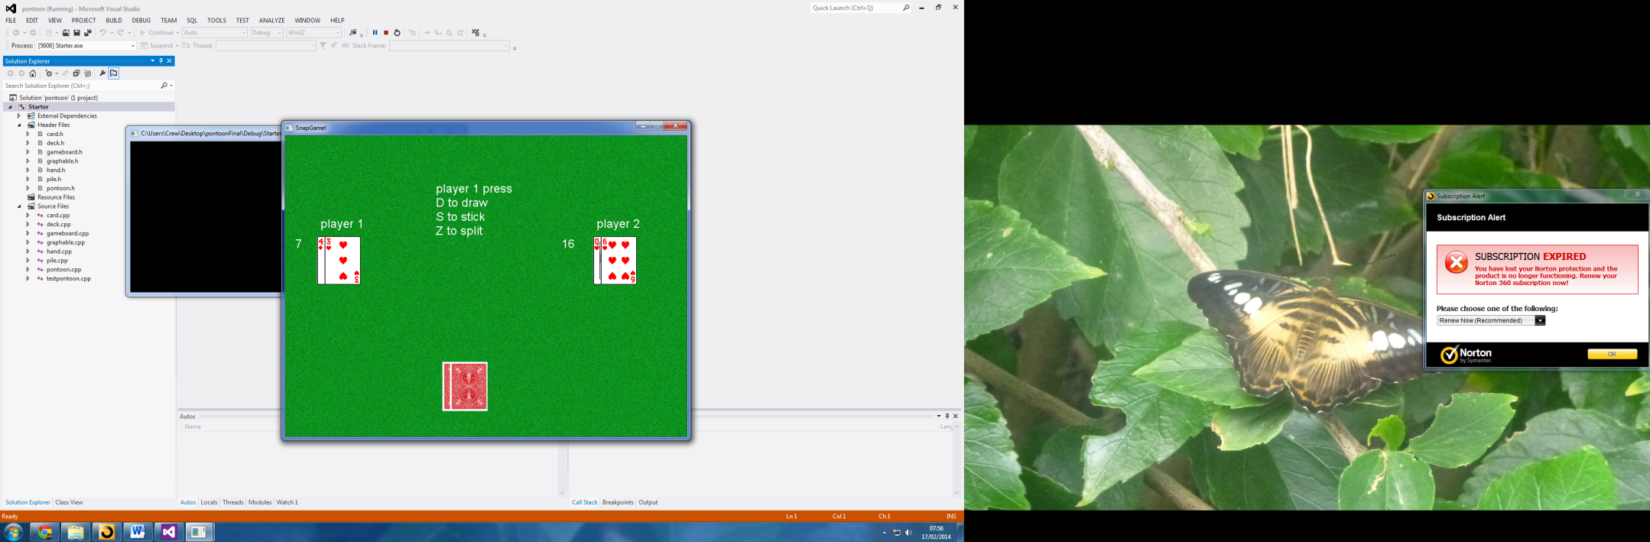

When: 2012

Tech: C++, SFML

Description: This is a pontoon style game I made using SFML in C++. It is a single player or a 2 player game. I wrote all the logic for the computer when playing single player. The player has the ability to split hands, draw cards until bust and stick. The computer will draw until it gets 16 or higher then will stick. There are different levels of 21/pontoon i.e. blackjack, 5 card trick and normal 21.

## Space invaders

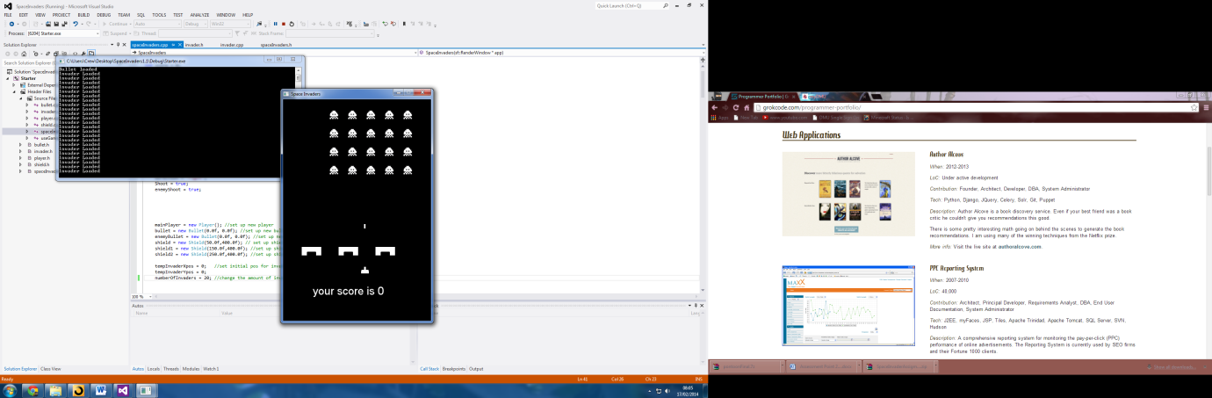

When: 2013

Tech: C++ SFML

Description: This is a space invaders game I made as my first year final project. You shoot the aliens coming down the screen at you, if they reach the bottom the game ends and you get a high score. The shields will be destroyed if hit to many times.

## Alien Escape

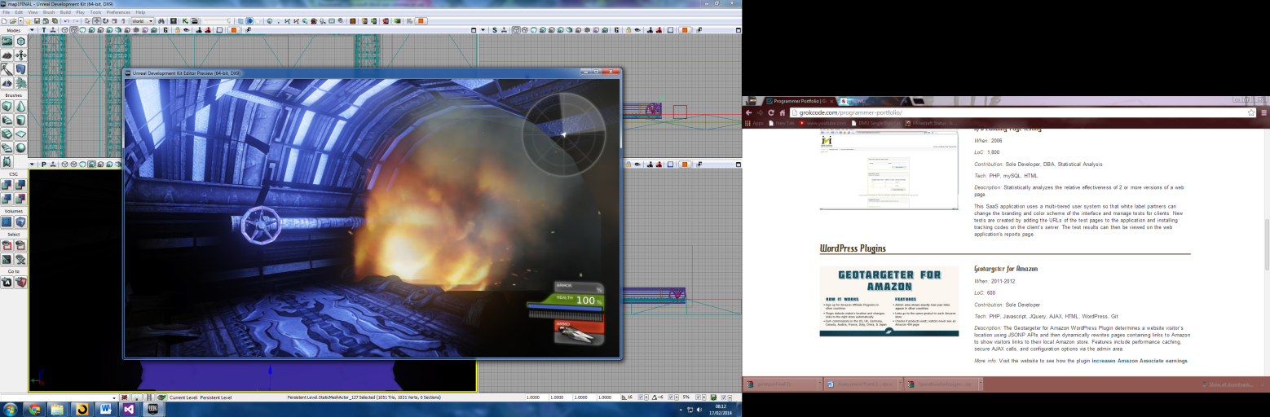When: 2013

Tech: UDK game engine

Description: I made this as a part of a group project. The brief was to make a game based on a movie. We chose to a game based on Alien. This was a puzzle based game with jumping puzzles and collectables. Throughout the game there are cut scenes puzzles to solve and quick time events.

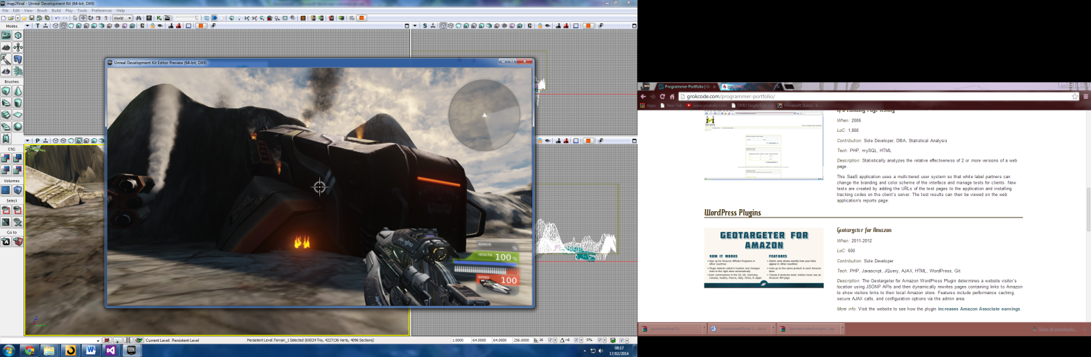

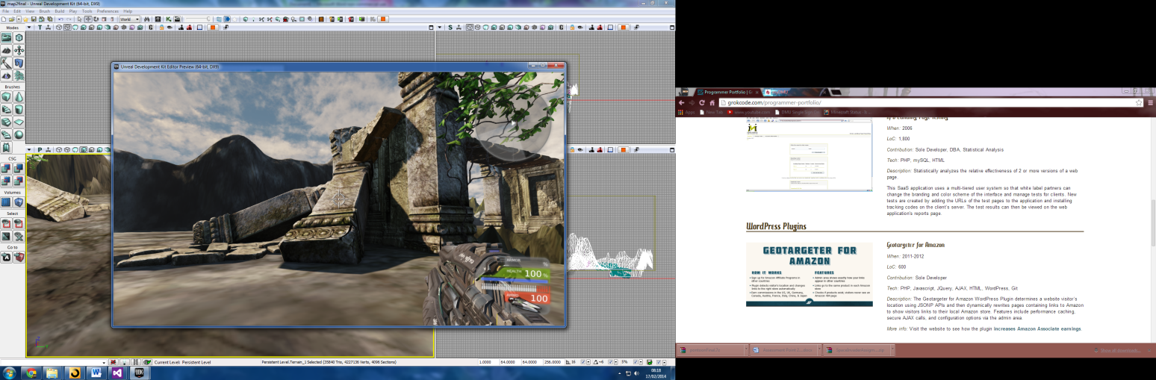

## Dave the Plumber

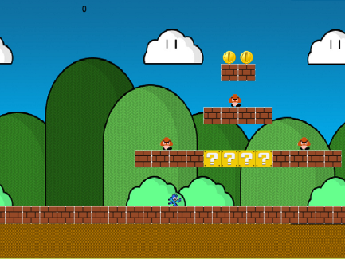

When: 2014

Tech: C++, SFML

Description: This was a project to make a platform game mad on the premise of “Dave the plumber”. The game featured enemies, collectables, static/destroyable blocks and power ups. I used a basic physics model for the jumping (Euler calculation).

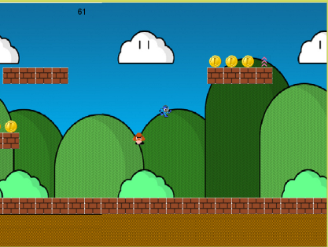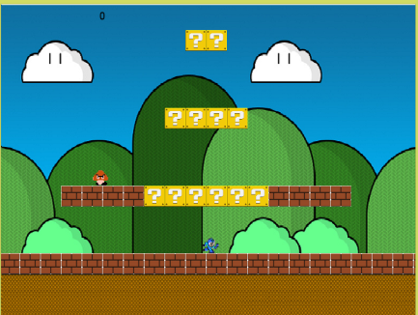

3D work

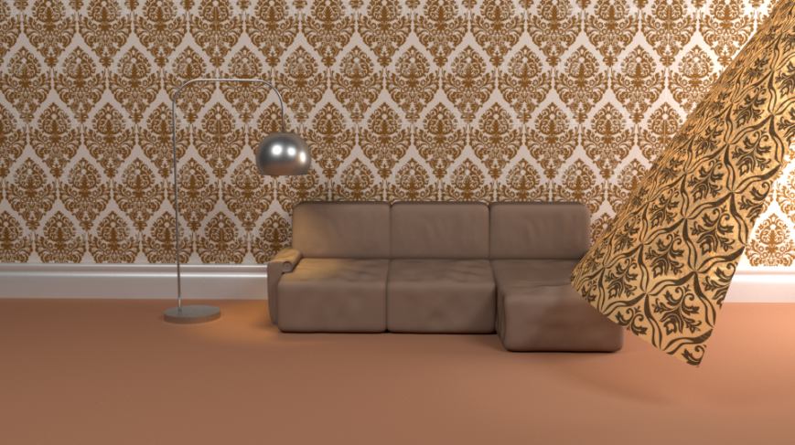

When: 2012 - 2014

Tech: Blender, GIMP

Description: These are some of my final renders of projects I have undertaken in my spare time. I am completely self-taught from books and internet tutorials.

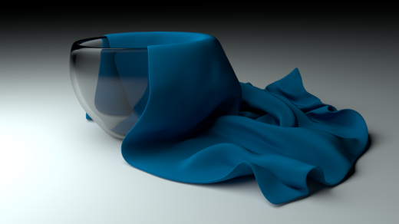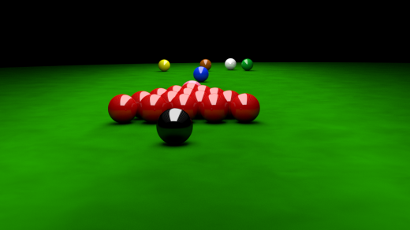

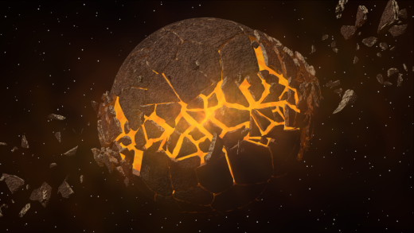

# Year 3

## Open GL

## Final Year

## Mobile

## Games Programming